**Recruitment Assignment for Backend Development**

***Spark Banking Application (Assignment)***

**Functionalities :**

1. Users are able to see the current balance.
2. Users are able to add money.
3. Users are able to withdraw money.
4. Users are able to see Transaction History.

**Technologies Used :**

* Frontend – HTML5, CSS3, Javascript, Bootstrap
* Backend – JAVA, JSP, Servlet, MySQL
* Framework - Hibernate

**Test Cases :**

**Login Page**

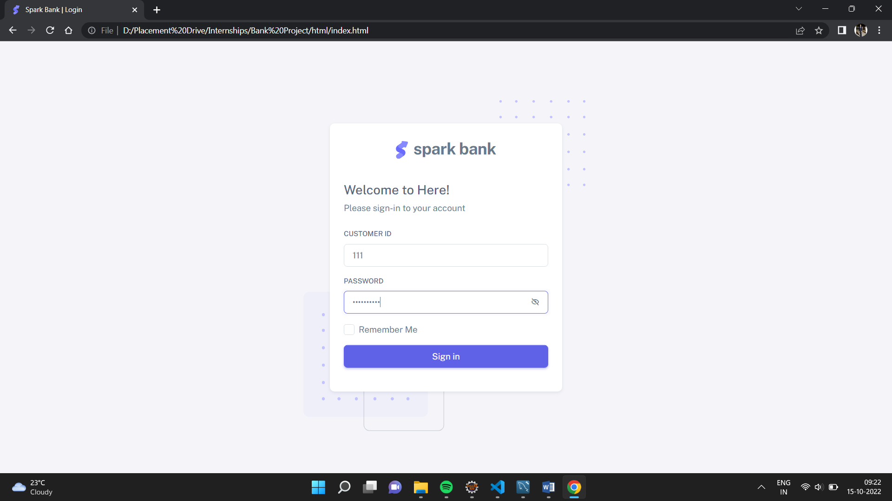

**Customer Dashboard**

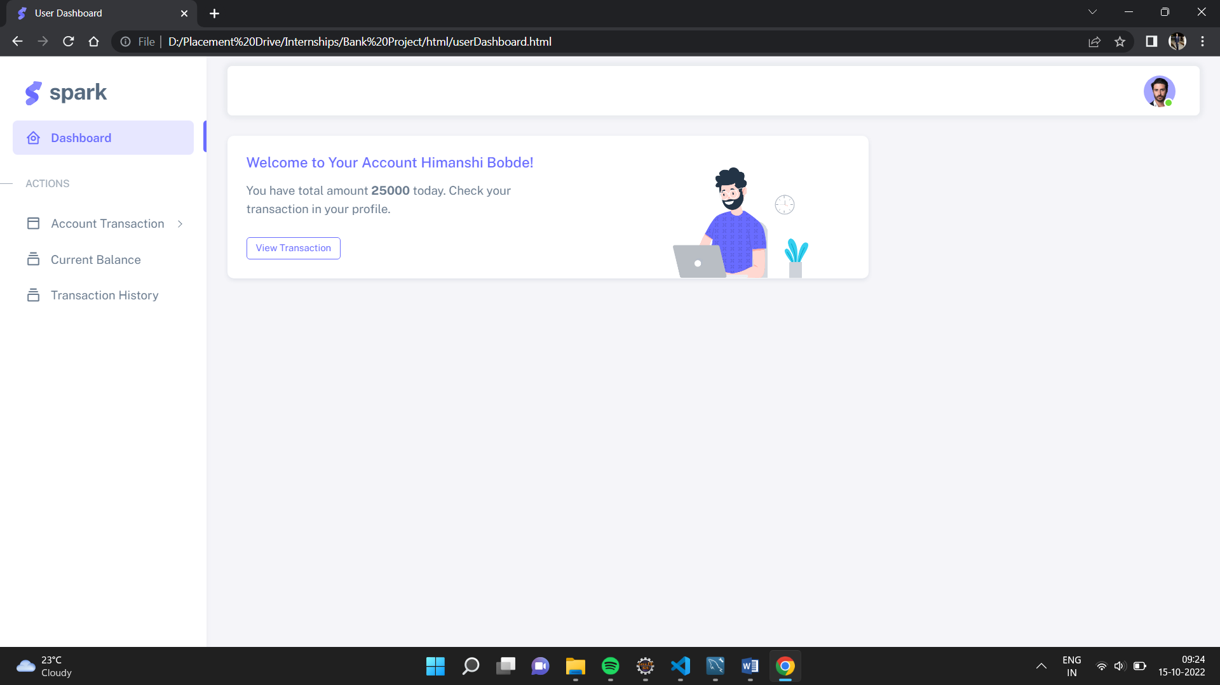

**Add Money to Account**

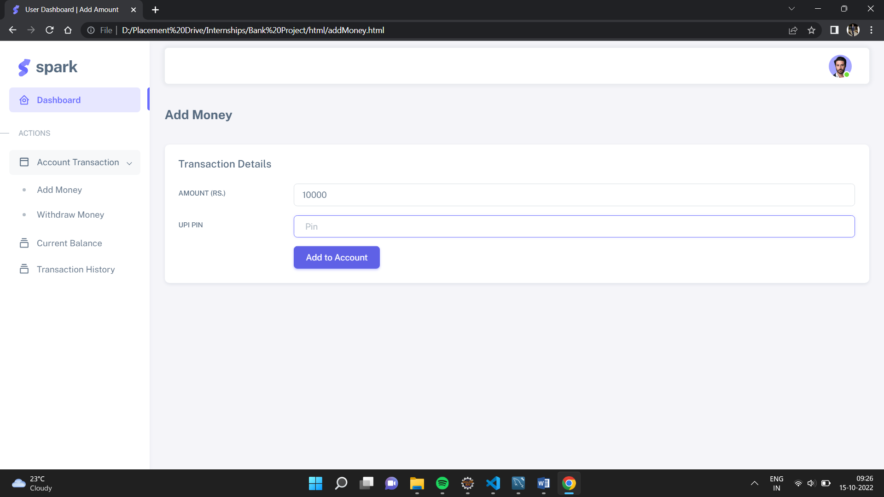

**Withdraw Money from Account**

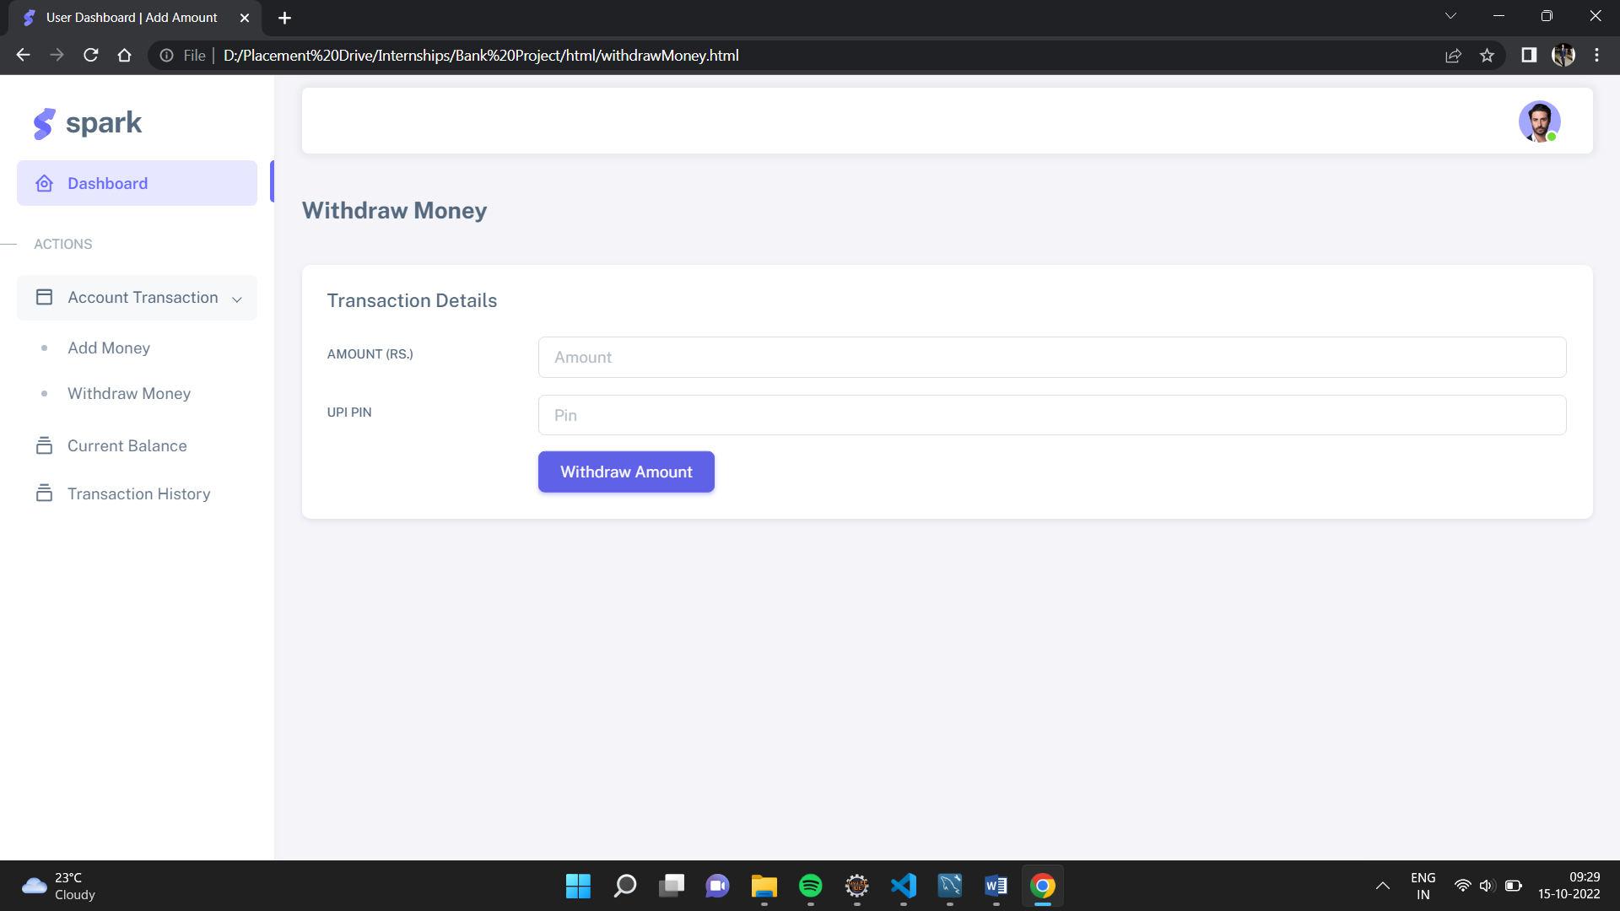

**Check Current Balance**

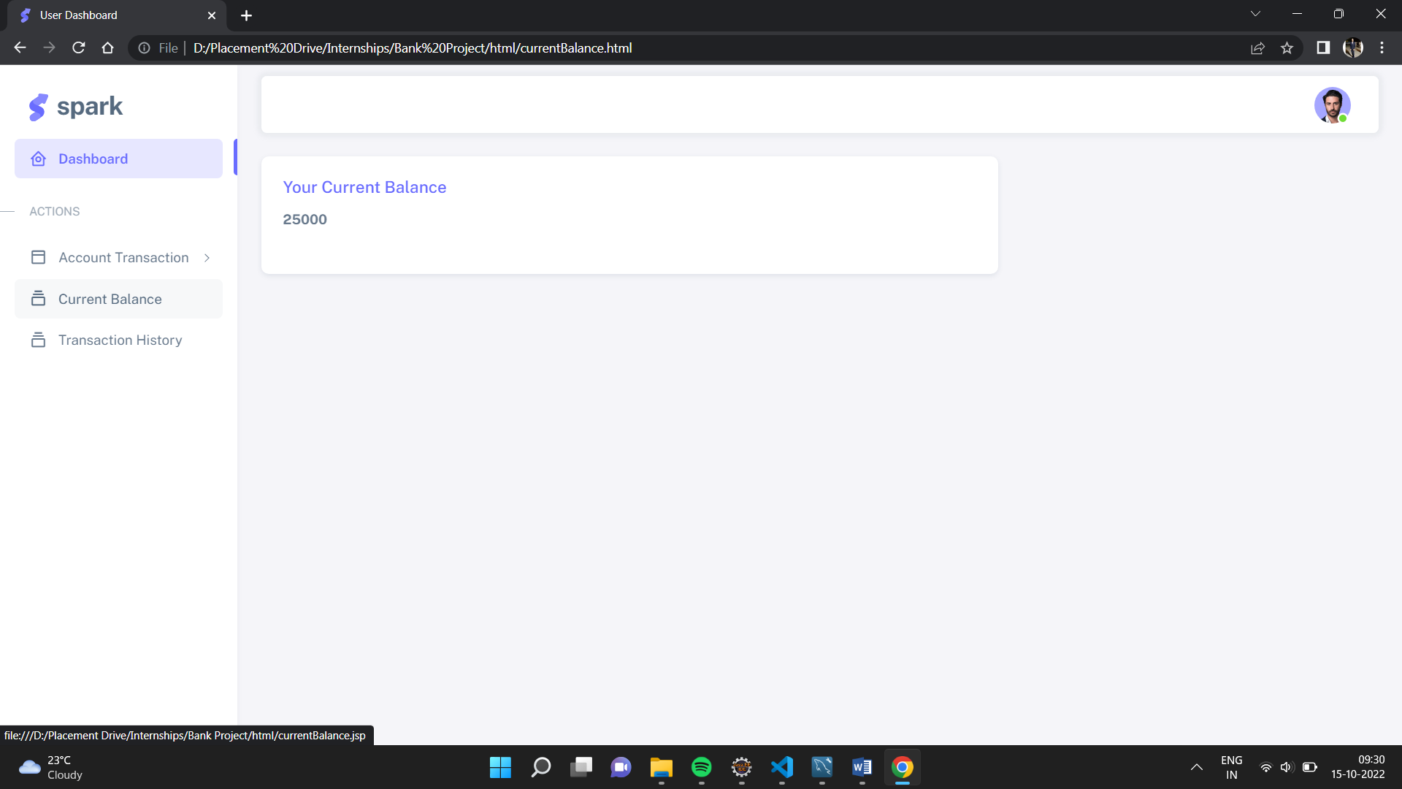

**Transaction History**

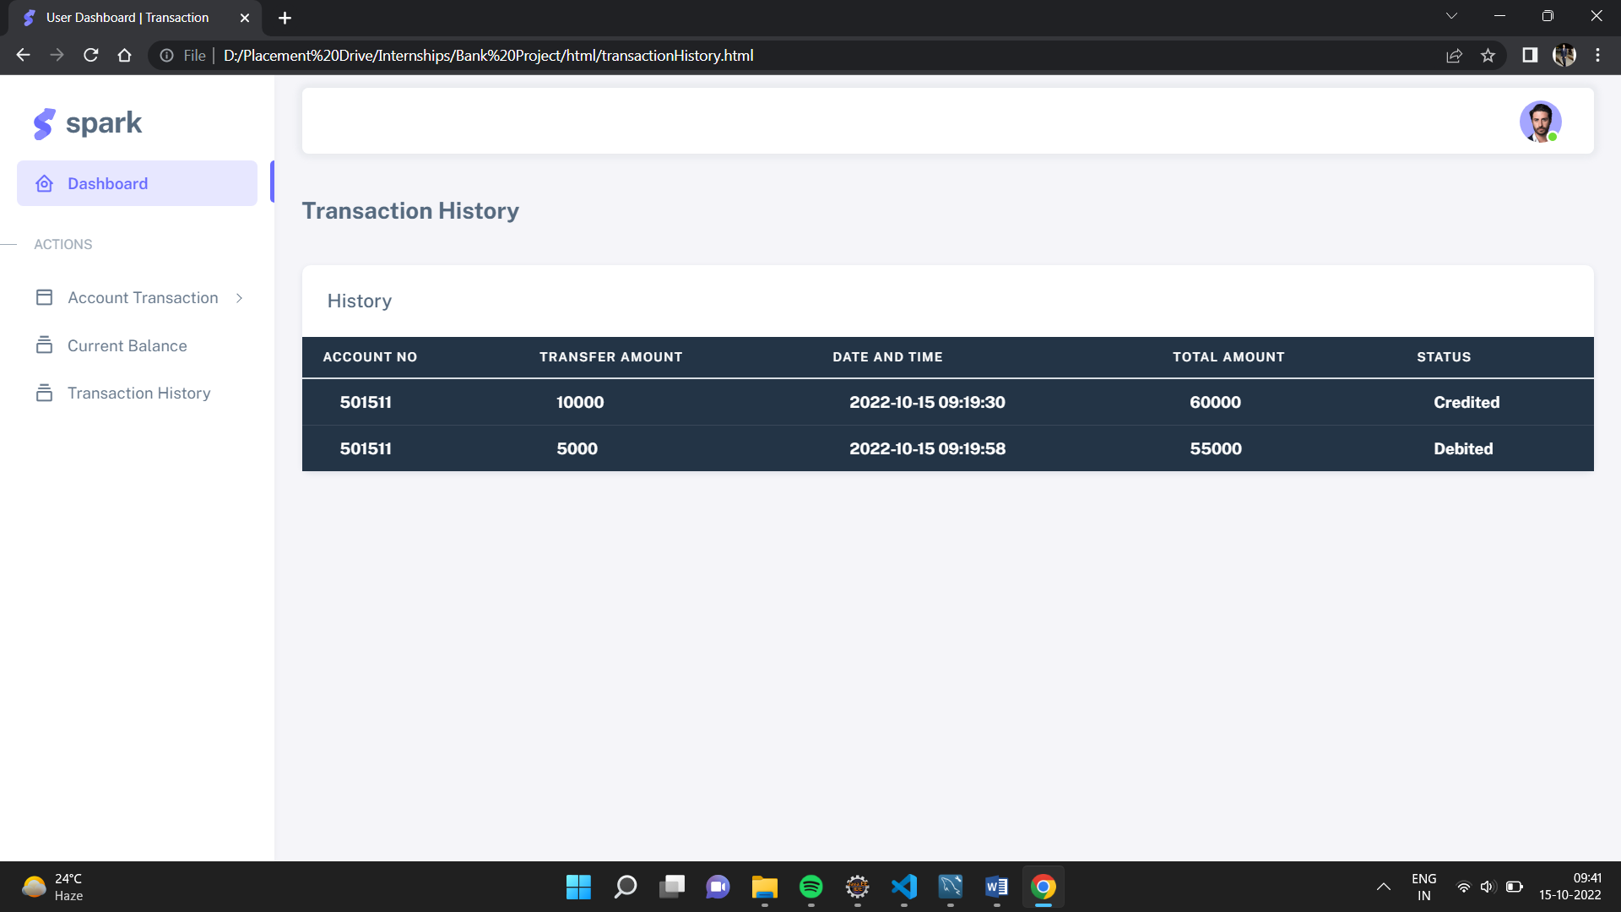

**Customer Details Table**

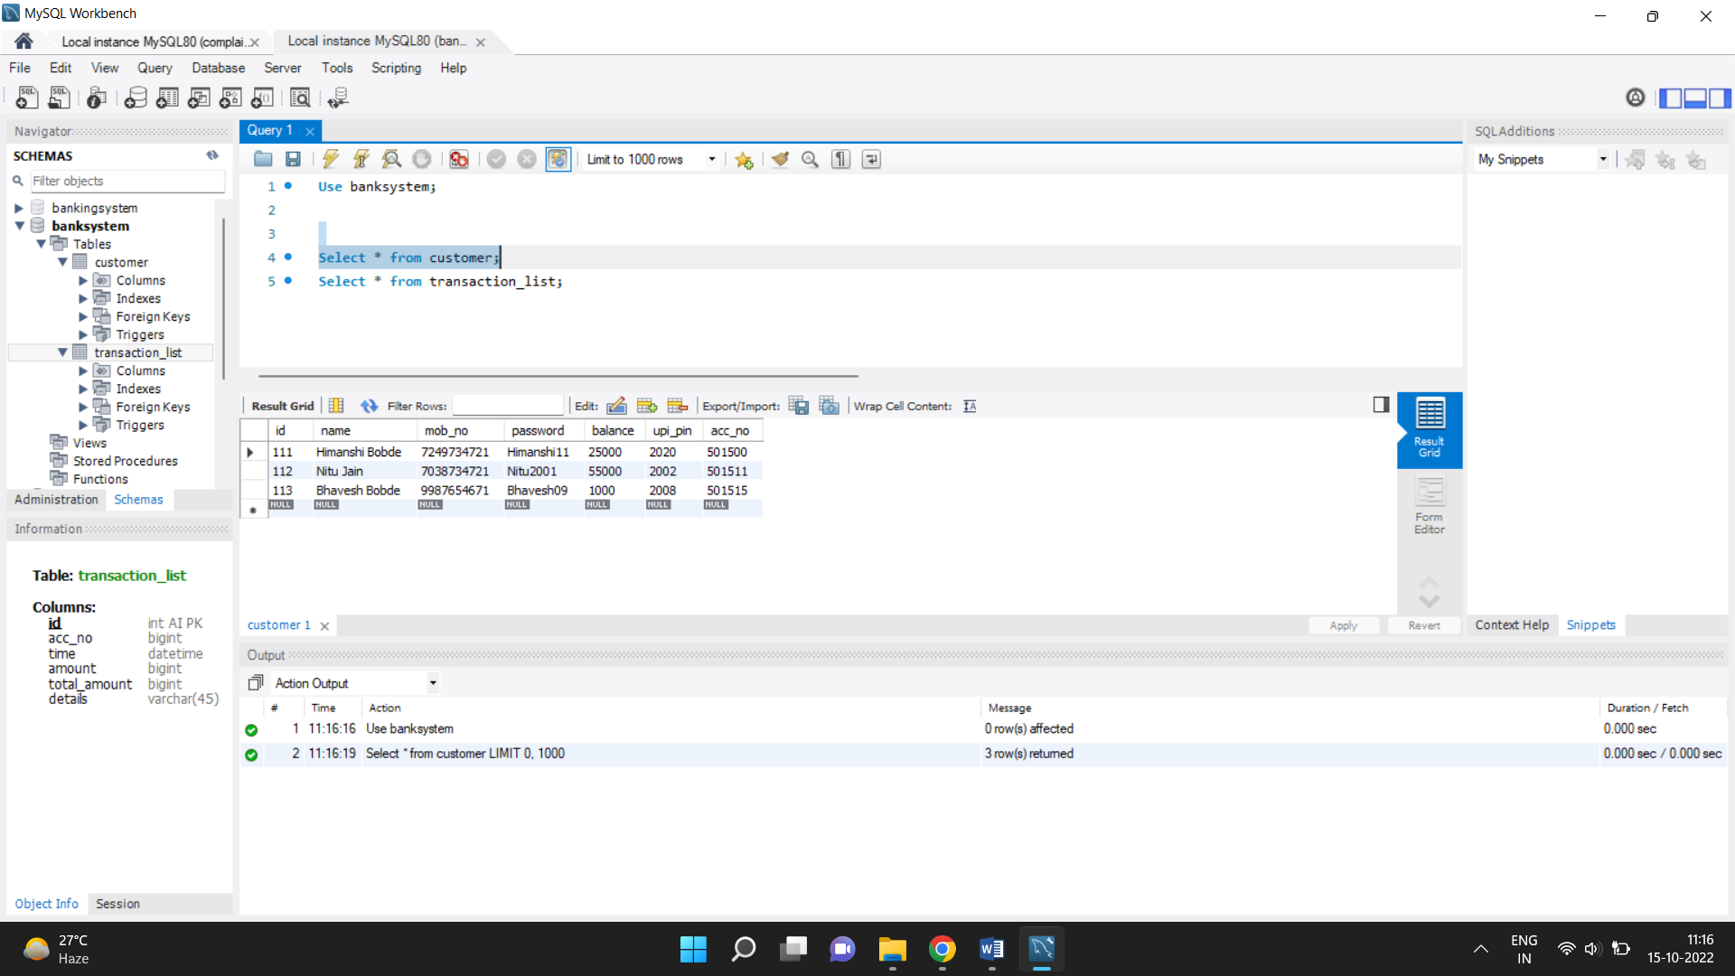

**Transaction History Table**

